27.6.2022

BBZW-Sursee; FMZ; Wang Hao

Documentation JavaScript-Game

Streetfighter Game

Inhalt

User-stories (After priority) 2

1. User Story 2

2. User Story 2

3. User Story 2

4. User Story 2

5. User Story 2

6. User Story 2

Wireframes/UI Design 3

User guide 4

Reflection 5

Journal 5

# User-stories (After priority)

## User Story

As a user of this application or a player, I want that the game can show who won between us, for example in health bar form or timed out from, that we can decide who is the winner of this game at last.

## User Story

As the developer of this application, I want to use object-oriented programming language, in this case JavaScript, with the combination with HTML, that I can fulfill the requirements which were giving to me to complete and follow.

## User Story

As the UI Designer of this application, I want my design to be clear and aesthetic, because the design shall be fitting to the theme street fighting game. For user, the design shall look clear, and not too complicated.

## User Story

As the developer of this application, I want to be able to fully understand the JavaScript behind it at the end, that this will help me in the future programming.

## User Story

As the developer of this application, I want that my application will work as error free as possible, that the users experience could be the best and that I can rather focus on upgrading on this application, not on fixing the bugs and the errors from the applications.

## User Story

As the Developer I wish I could publish my application on GitHub or on other platforms, that this will be displayed as a project I have done.

# Wireframes/UI Design

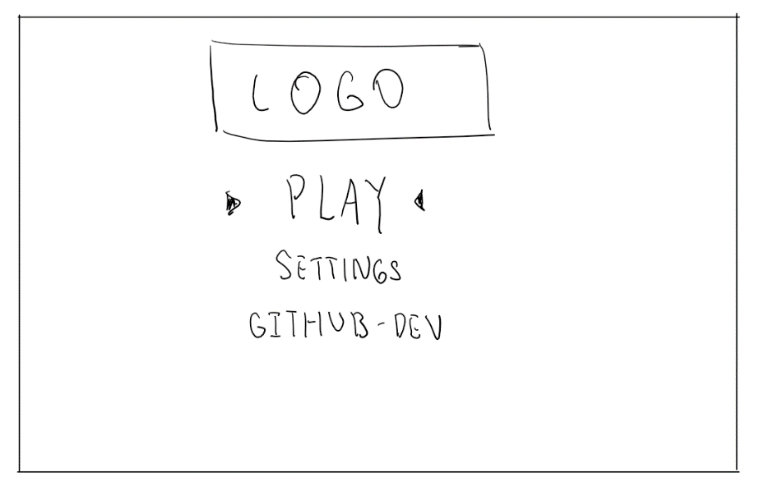On the main page you will be able to see a fitting background, a logo which I will be designing by myself, and then underneath it 3 different buttons. The 1st one is a button for play, the 2nd one is for settings, and the 3rd one is a link to GitHub repository, where all the commits and files going to be. And this is the Wireframe to the main site.

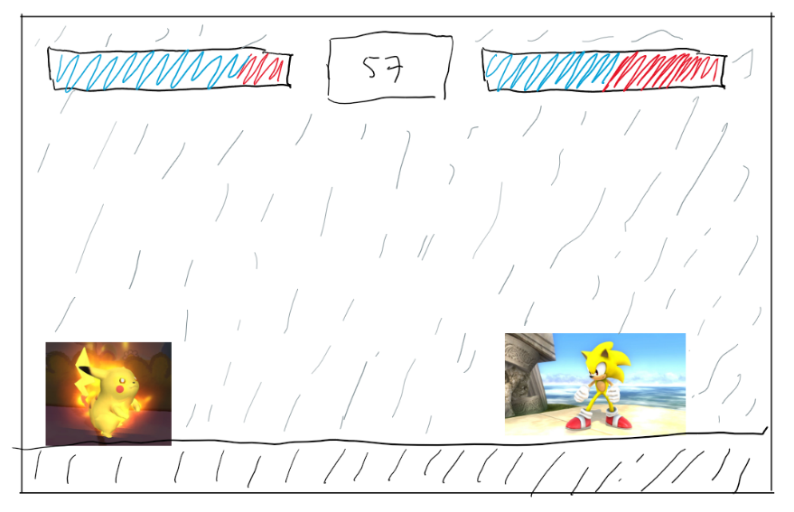

At this Wireframe (right) you can see how the main site is going to look like. In the top middle you can see a counter which is going to count 1 minute down. Next to the countdown you can see the heath bar. The blue one is which you still have, and the red one is which you have already lost. It is going to be 2 characters “fighting” against each other, also with the fitting background and a floor.

# User guide

Main Goal: In this game, the main goal is defeating your enemy or the other player.

Health bar: Both players have a health bar, the health bar will go down if you are getting hit by the enemy player. Each hit cost a 1/5 of a players health bar, after 5 successful hits, one of them is going to win.

Time limit: there is a time limit of 60 seconds, when after these 60 seconds no one is getting defeated, the winner will be decided by the health bar percentage. When each player has the same amount of health bar in 60 seconds, is a tie.

Movements: Player 1 movements: || W -> jump || D -> move to right || A -> move to left || space-bar -> attack ||  
Player 2 movements: || Arrow up -> jump || Arrow right -> move to right || Arrow left -> move to left || Arrow down -> attack ||

This is the complete user guide for this game.

# Reflection

This project was a rollercoaster in all kinds of ways. The problem is I am using a canvas for the first time, and this is also my first-time programming “player” movements and different animations in JavaScript. This was difficult for me, because I need to understand all the codes I’m writing, and I need to code it flawless. Else one small mistake can crash the whole program. When I first start the project, I had a good feeling about my planning, but I came to a real stress at the end because the project took way too long then I thought. There are still some issues which I didn’t fix, which are the player and enemy can jump out of canvas, they can walk out of canvas, the game is still “playable” after timed out, and the players can’t walk backwards, they can only walk one direction. The time is saying no for fixing these issues, but I’m surely going to fix them in the future and finish the game. But the result is good enough and I’m happy about it :).

Like you see on the wireframes, it should have two sites. Unfraternally, I didn’t manage to program the first site because the main site took way too long. But in comparison I managed to implement my main site wireframe perfectly.

There was also a lot of issues during programming. For example, the animation didn’t want to work, because the frames were calculated wrong, or the frames were defined wrong and so on. One big issue was also the attack of enemy didn’t work that well. At the end I found out it was just a “{“ which cost the problem. But as I said, the result is good and working.

## Journal

Due to the miss seeing from myself, I didn’t write a journal every single day where I write down what I have been doing for this Program. Instead, I’m going to write a journal which describes it in roughly.

On the 6th of June, we received our assignment about this project. At that day, I concluded that I want to do a fighting game with JavaScript. On the same day, I finished my user stories and my wireframes.

On the 13th of June, I started coding for my project. On that day, I declared my canvas, is also where my game will be.

Due to my git commits, on the 17th of June, I successfully created my player and enemy element. As I remember, it was only the rough looking of my player and enemy element. On the 19th of June, I was able to move my characters with event listeners. Later that day I successfully manage to program player attack movement, but there was a bug on the enemy attack movement site.

And finally, today, the 20th of June, I finished my whole project. The details are in my git commits. But what I did mainly today is the design of the game, testing all the functions and classes, document my code and my documentation for my project.